Week 2- Lab Session 2

Practice with if-else Statements and Loops in Python

Objective:

Students will analyse and modify Python programs using if-else statements and
loops, explain how these structures control program flow, and present their findings
to demonstrate understanding.

Scenario 1 Age verification:

Tasks:

- Modify the code to check if the age is a negative number and display an error message
- Add another condition to classify users as senior citizens (65+)

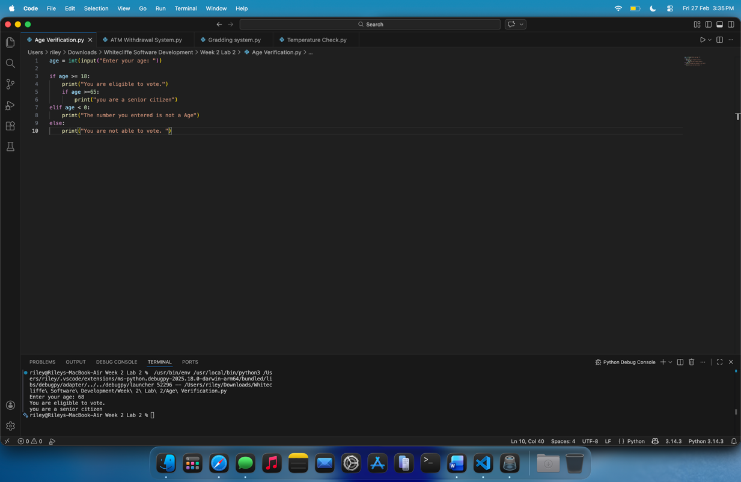

Scenario 2 Grading system:

Tasks:

- Modify the code to handle edge cases (negative scored and scores above 100)
- Add feedback messages for each age

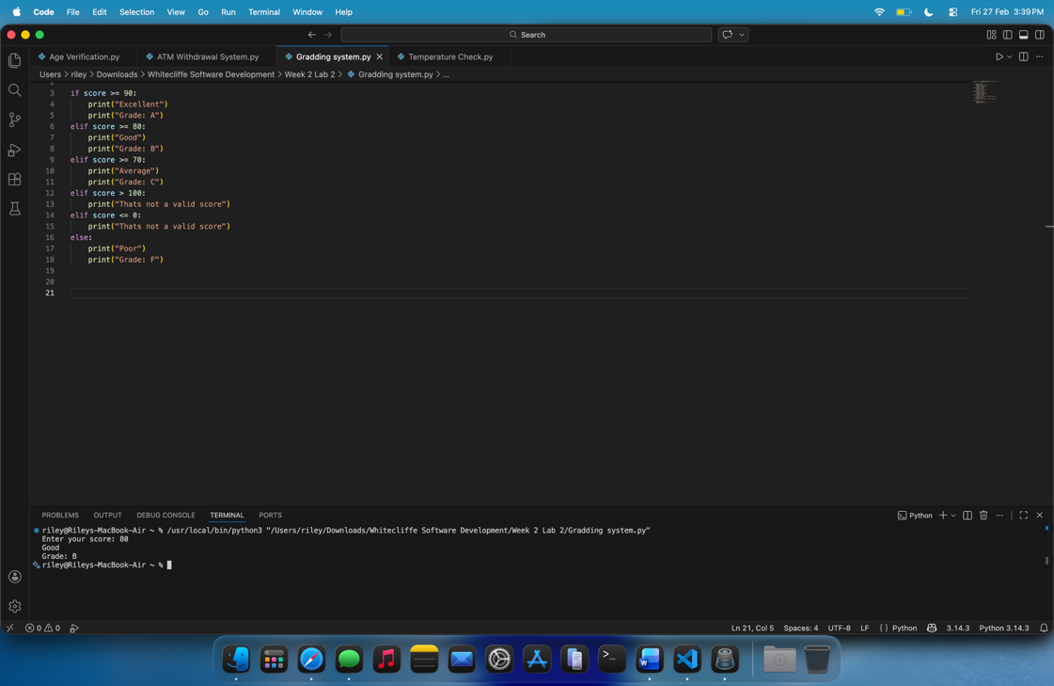

Scenario 3 Temperature Check :

Tasks:
- Modify the program to convert the temperature from Fahrenheit to Celsius before applying any conditions.
- Add a condition to check if the input is too extreme (above 50 degrees or bellow 30 )

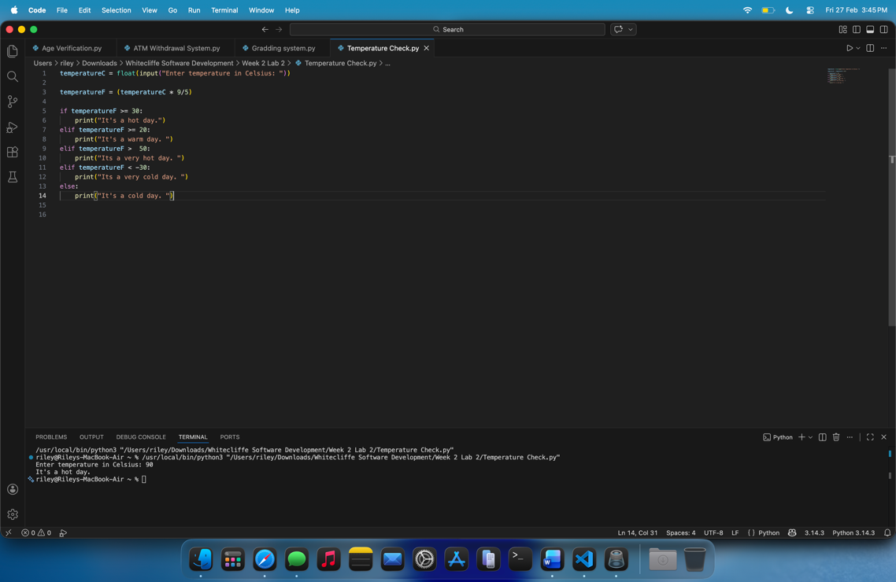

Scenario 4 ATM Withdrawal System :

Tasks:
- Modify the program to convert the temperature from Fahrenheit to Celsius before applying any conditions.
- Add a condition to check if the input is too extreme (above 50 degrees or bellow 30 )

